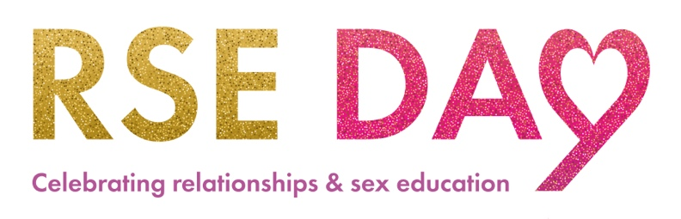

RSE Day 2022 ‘Welcoming Spaces’ resources with Rachel Scanlon

Celebrating differences - Everyone can sparkle!

In this pack you will find everything you need to create 3 different star-based artworks. (I have linked to Amazon, but your school may have accounts with another supplier who stock similar items.) You can adapt an activity to suit your setting – be creative!

1. The printed sheet RSE Day Easy star could be sent home with every pupil or worked on in school. You will need colourful felt tips or crayons, scissors and a bit of sellotape. You can find a PowerPoint here if you like to work that way.

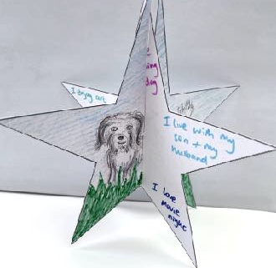
On each point of the first star write the answer to one of these questions: (pick 5)
  - What makes you sparkle?
  - What is your favourite thing to do?
  - Who do you love?
  - Who is in your family?
  - What makes you proud of yourself?
  - Where is your favourite place?
  - What do you do to relax?
  - What makes you happy?
  - What do you do for fun out of school?
  - What is your favourite colour/texture/material/sound/sensation?
  - What are your strengths?
  - What is your best achievement?

On the second star draw a picture to represent one of your answers. Cut them out. You can draw pictures about you or add patterns to the back of both stars too.

The stars slot together and can stand up - I usually add a bit of tape to a couple of corners where it joins together to help keep its shape.
Now compare your answers to other answers in class. Think about these and discuss:
  - How are we similar/different?
  - How do our differences make us stronger?
  - Why is it important to respect differences?
  - What would happen if we were all the same?
  - How are we unique?
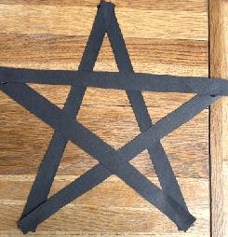
The finished stars can be displayed on a surface for all to see or could be hung up in a reception area / hall to create a whole school exhibition with impact.

2. The next star activity is to make a stained-glass window piece of art, involving cutting and gluing.

Each pupil needs half a piece of black A4 paper - cut length ways. Cut the black piece of paper into 5 strips, along the long length. Arrange to make a 5-point star shape (start with an A shape). Then glue each corner - PVA or glue sticks.

Next hold your selected coloured piece of tissue paper over the area you want to stick it and draw along the OUTER edge of the black paper outline - so the tissue paper piece is bigger than the hole but doesn’t overlap the black outline. Cut along your lines. Glue around the outline on the BLACK PAPER (again PVA or glue sticks) and stick the tissue paper in place.

Repeat for all the gaps - with the glue all going on the same side. This is the back and will be messy, the front will stay neat. (NB if you turn it over to look at the front during the making process, make sure to turn it back again so you are always gluing and making a mess on the reverse side).

Now refer to the above questions and write your answers on the black edge using white/pale crayons, chalk, pastels or gold/silver pens (normal pencils do show up when they catch the light, so could be used).
Compare your answers to your friends and discuss similarities and differences.

A whole school exhibition could be created across windows in school so visitors/parents can see from the outside, or they could be laminated and hung on the school fence/from trees outside. Either way they will catch the light beautifully creating a collaborative stained-glass effect.

3. The final star activity involves a bit more making.
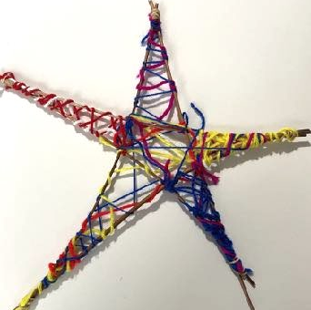
You will need 5 lengths of willow to create the outline of a star. You can use tape, pipe-cleaners, elastic bands, sandwich bag tags, string or wool to join the corners together.
Now think about the questions above, and what your answers might be.
What is most important to you?
Look at the lengths of wool supplied and use the longest piece to represent the most important answer to you. Tie the piece of wool to a star point and begin wrapping the wool around the star structure. You can zig-zag across the star or wrap around the sticks.
Use the next size down length of wool for your next most important answer, and so on until you have 5 colours on your star.
Add the label to your star which tells us your most important answer and tie onto the woven star. Compare your star colours and answers to others in your class.

You can make an exhibition with these en masse by hanging them from the school fence or a tree for parents and visitors to see. For RSE day you could have extra labels for parents/visitors to add their answers too.

BEFORE making these stars, you could take a class trip to a park to collect 5 sticks/twigs each. You could create a huge class/group one with big found sticks or cardboard tubes that everyone can add to, or mini versions using lolly sticks. Alternatively you can create a recycled star using old felt tip pens that don’t work, straws, twigs, pipe cleaners, dowel rods.
To make the stars even more unique, children could add beads, stickers, bells, pipe-cleaners, ribbons or any other craft materials you may have in school to their finished star.

